**POWER BI PROJECT**

**BANK LOAN PERFORMANCE ANALYSIS**

**DATASET OVERVIEW**

* THE DATASET, Titled “Bank loan xlsx”. Contains of two sheets
* **Loan details**: This sheet provides detailed information about each loan, including the loan amount, term, interest rate, and loan status.

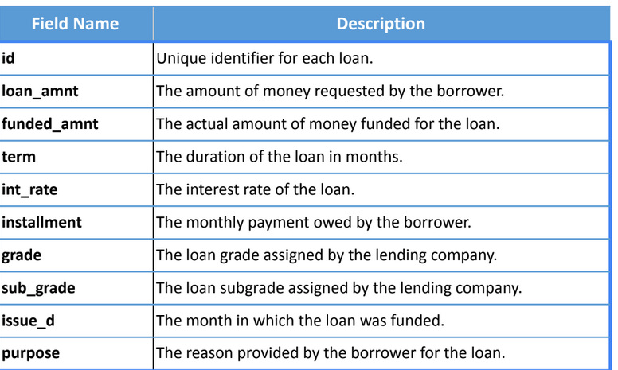

* **Borrower details:** This sheet includes borrower-specific details such as employment length, annual income and debt-to-income ratio.

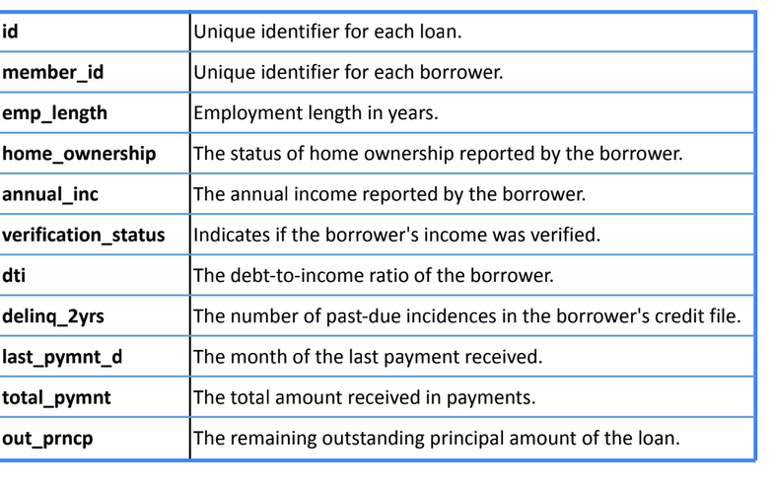

IMPORTING DATA

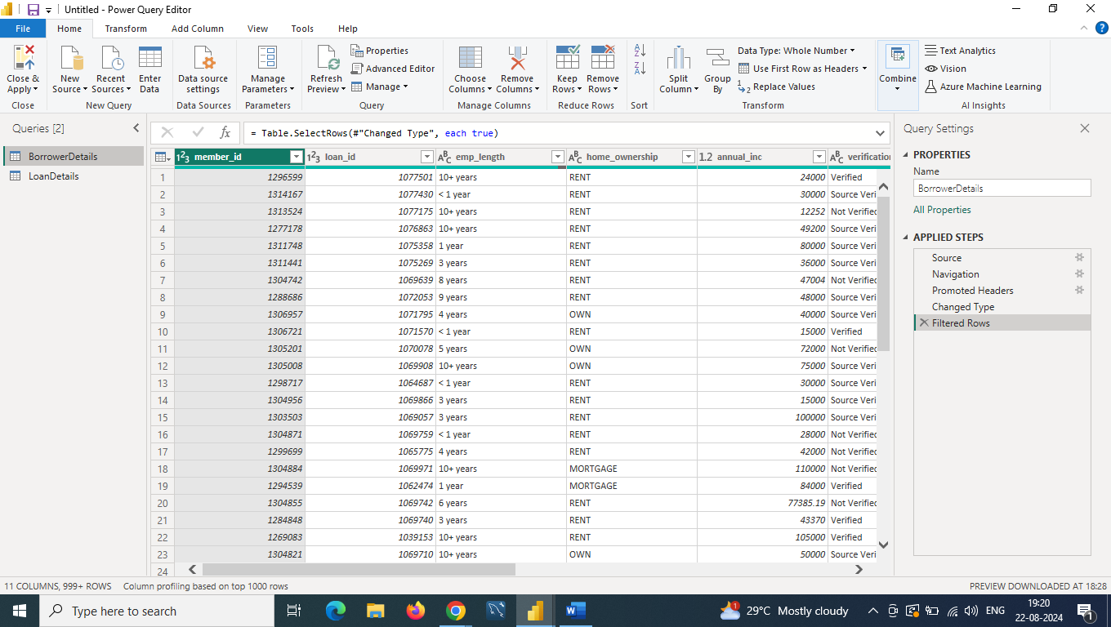

DATA CLEANING

**Replacing Missing Values**

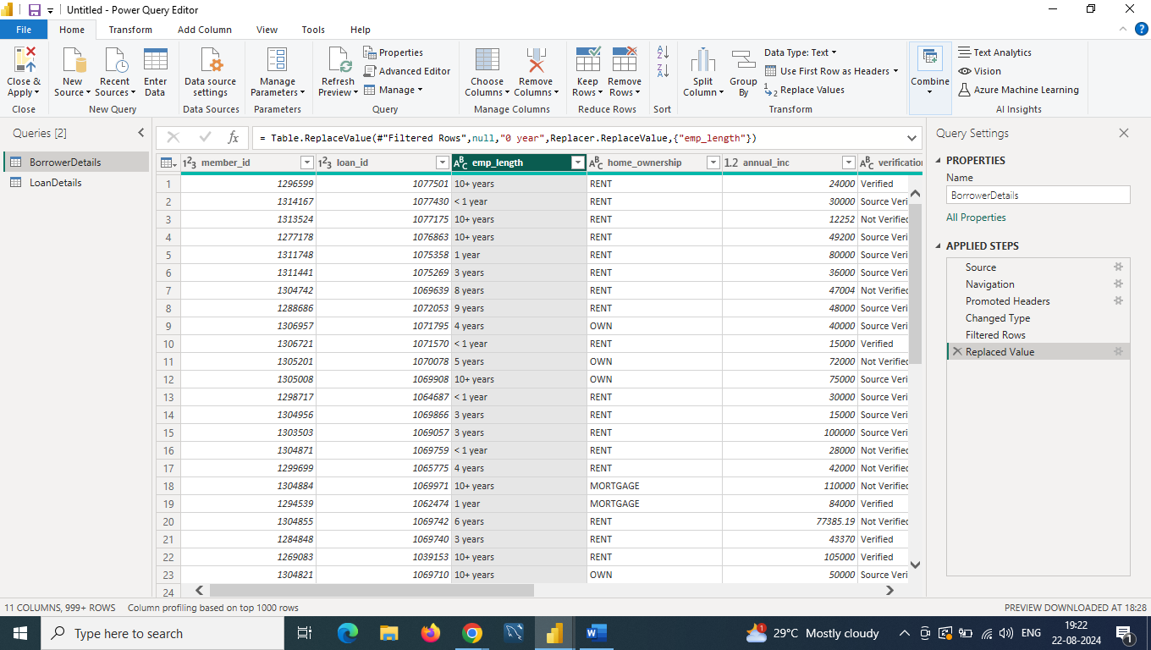

**Remove Rows with Missing Values**

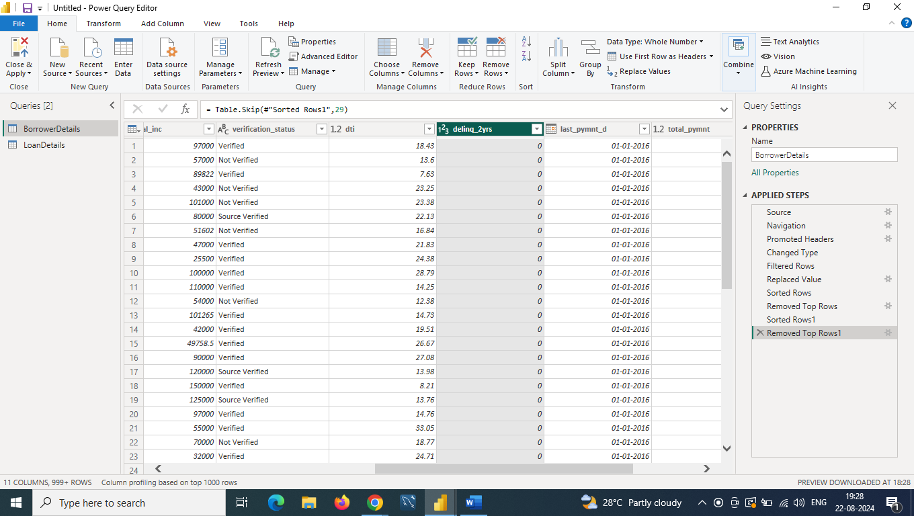

**Remove Duplicate Rows**

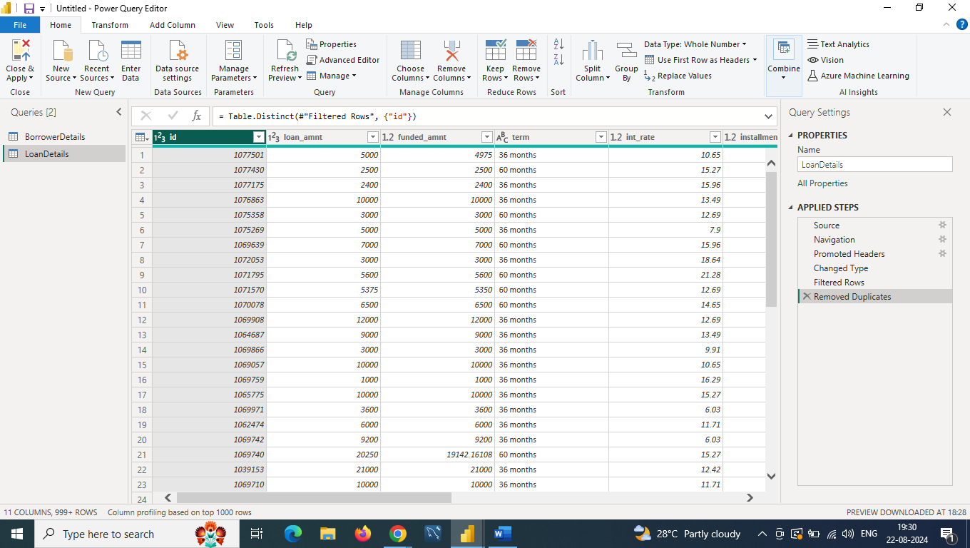

**Dealing with Inconsistencies**

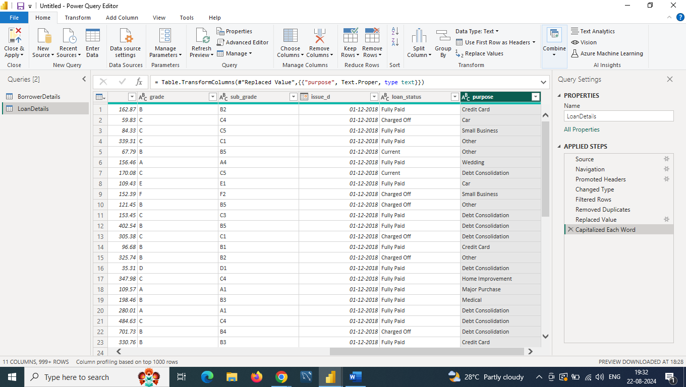

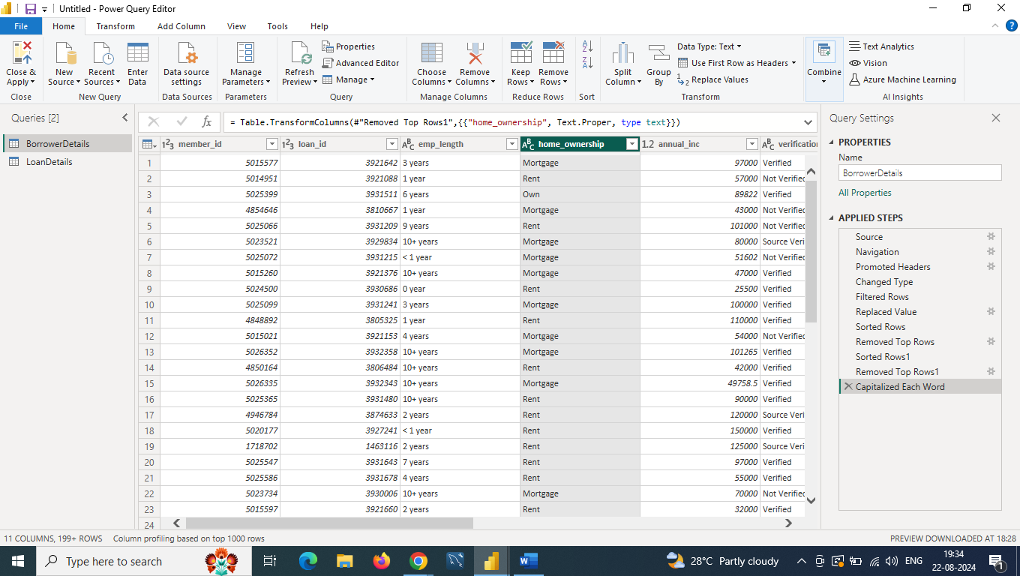

**DATA TRANSFORMATION**

**Fixed Decimal Number**

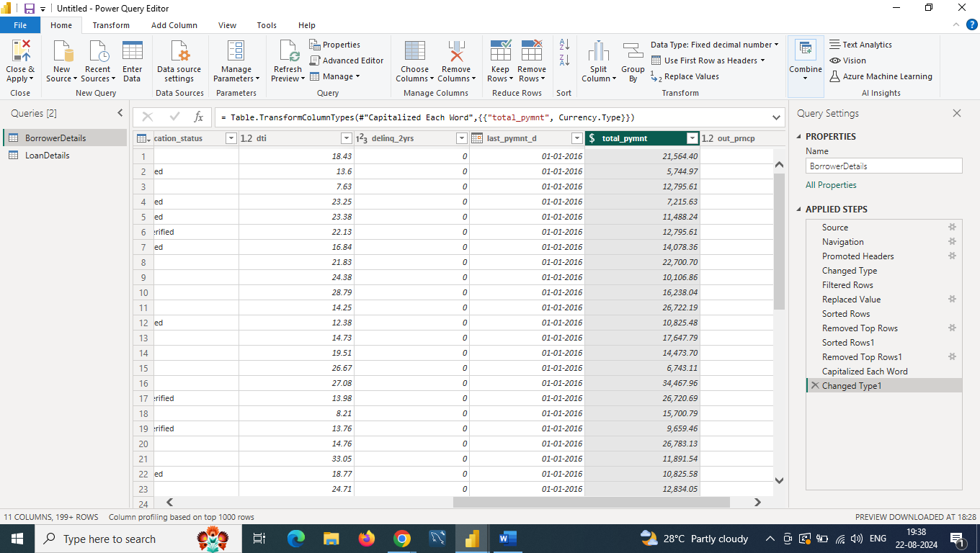

**2 Decimal Places**

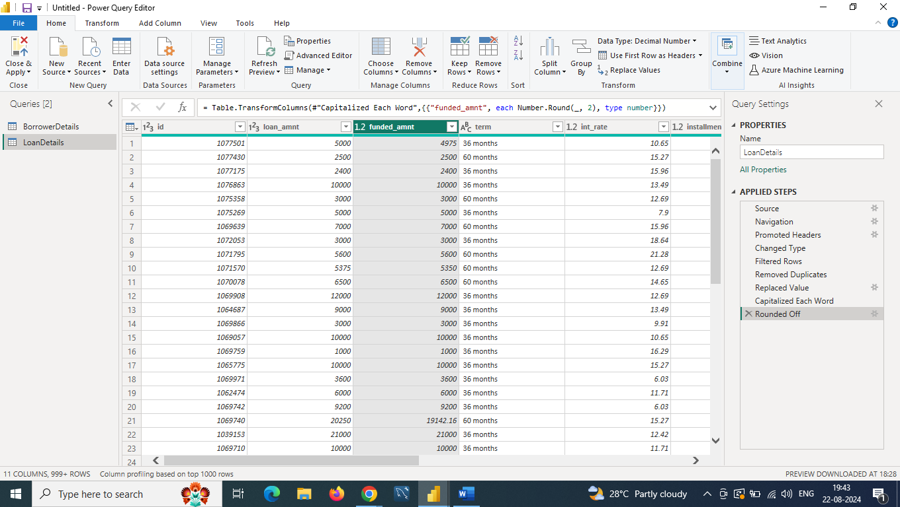

**Issue_d to issue_date**

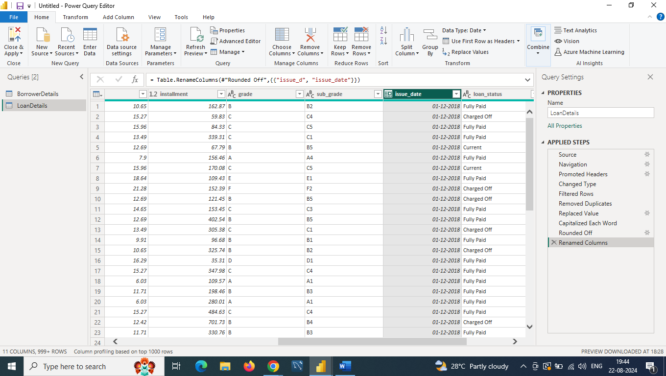

**Last_pymnt_d to last_pymnt_date**

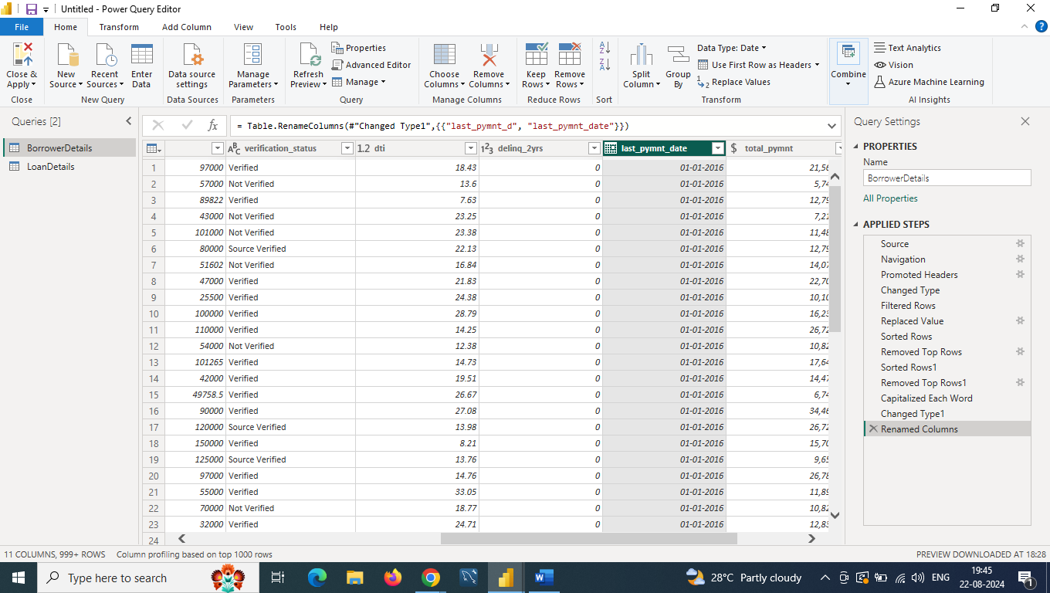

**total_amount_paid**

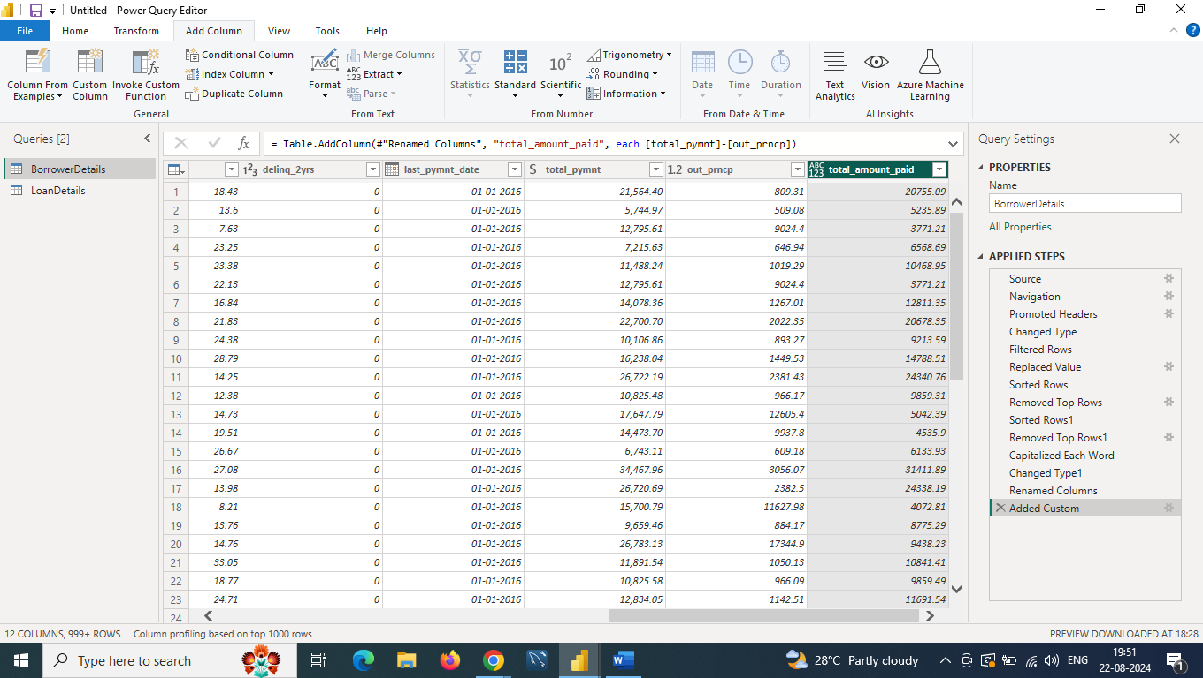

**Delinquent and Not Delinquent**

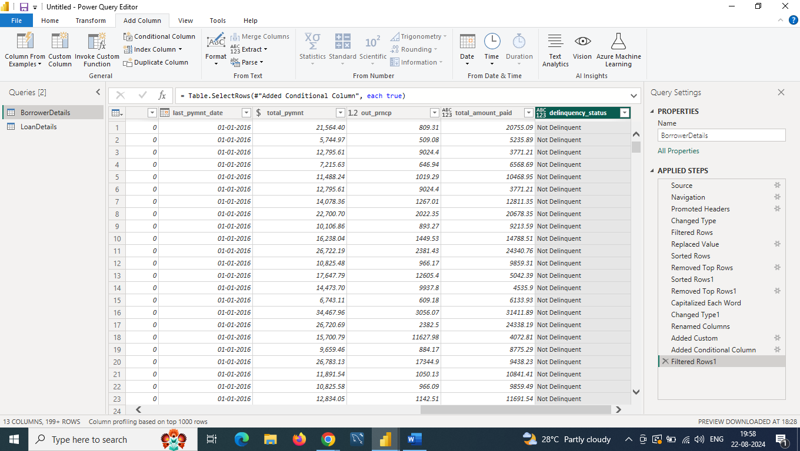

**Remove sub_grade**

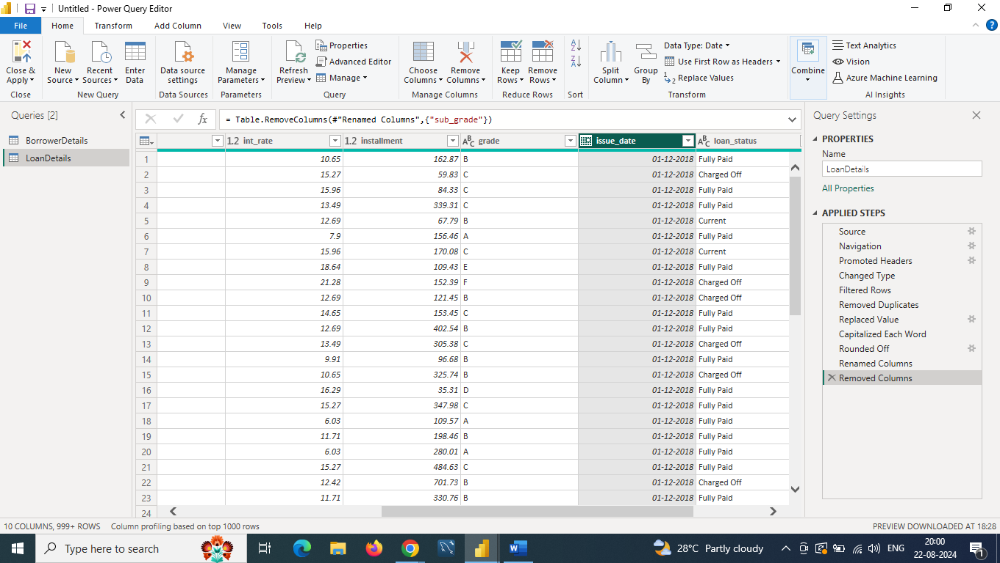

**DATA MODELLING**

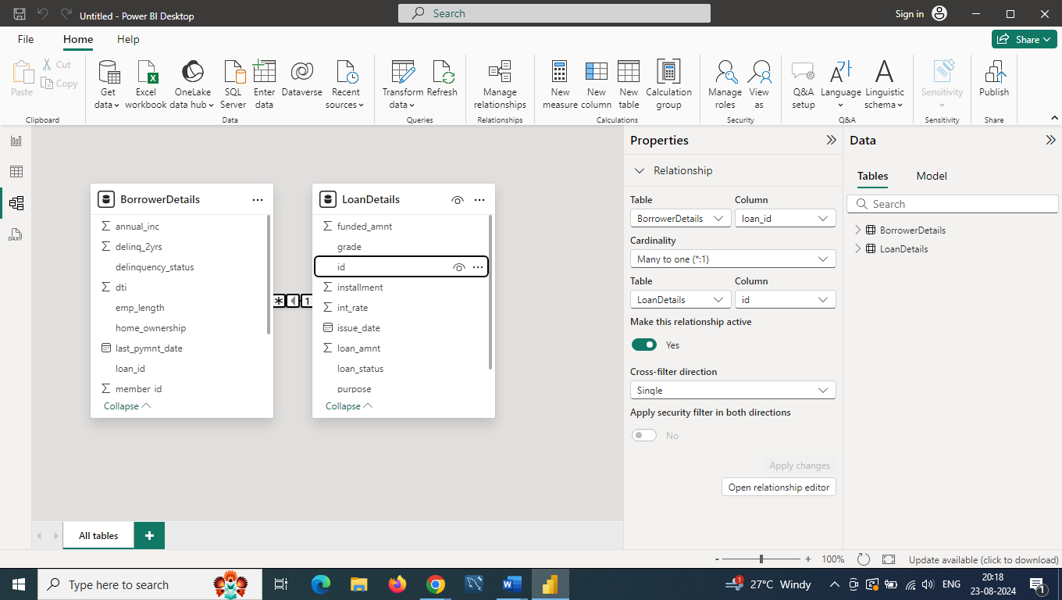

**Creating Measures and Calculated Columns Using DAX**

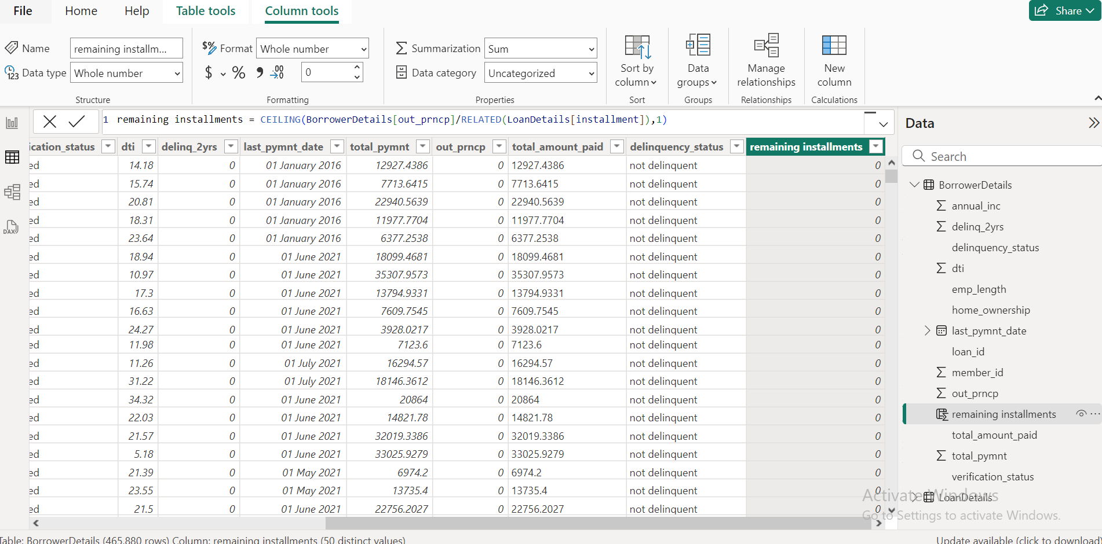

**Non-Verified Borrowers Count**

**Non verified_Borrowers_count = COUNTROWS(FILTER(BorrowerDetails,BorrowerDetails[verification_status]="NOT VERIFIED"))**

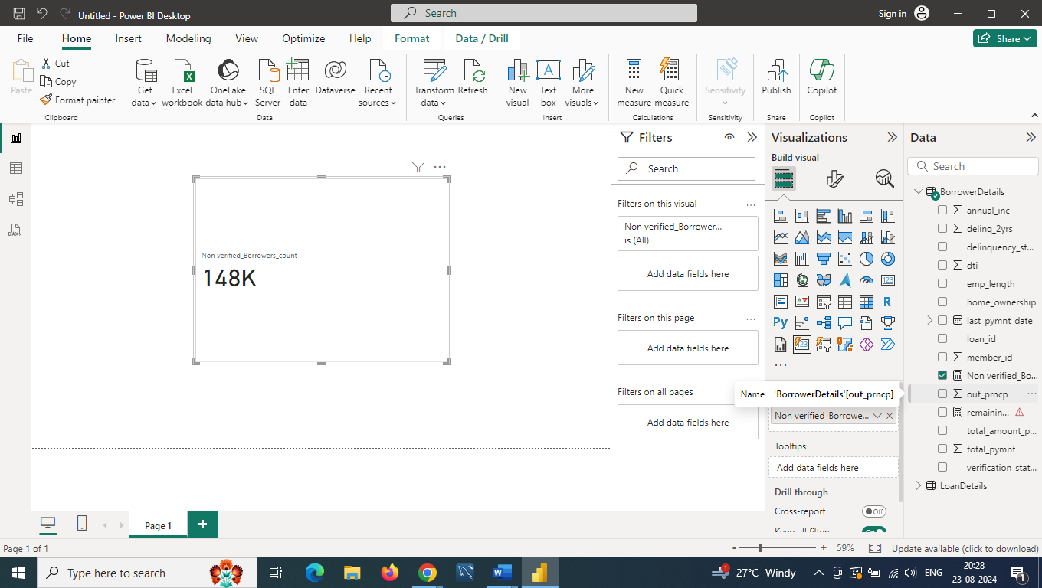

**Fully Paid Loan Percentage**

**Fully paid loans percentage = DIVIDE(COUNTROWS(FILTER(LoanDetails,LoanDetails[loan_status]="FULLY PAID")),COUNTA(LoanDetails[loan_status]),0)**

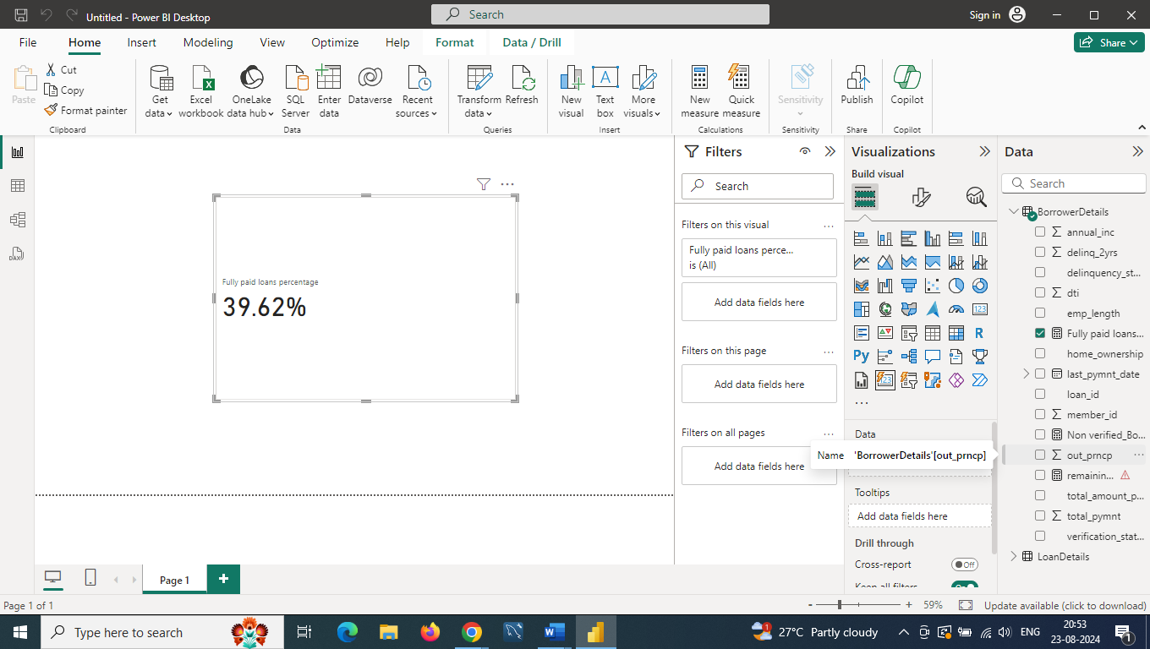

***Creating Comprehensive Reports***

**★ Report 1: Loan Performance Analysis**

**★ Report 2: Borrower Profile Analysis**

**REPORT 1 SUMMARY**

|  |  |
| --- | --- |
| **VISUAL** | **PURPOSE** |
| **CARD VISUAL** | **Display total funded amount** |
| **GAUGE VISUAL** | **Shows “fully paid loan percentage”.** |
| **MULTI-ROW CARD** | **Shows average interest rate by loan term** |
| **PIE CHART** | **Visualizes loan status distribution by total payment** |
| **TREE MAP** | **Display average loan amount by purpose** |
| **LINE CHART** | **Visualizes instalments over time by year and quater** |
| **COLUMN CHART** | **Shows maximum total amount paid by loan status** |
| **FUNNEL CHART** | **Display minimum annual income by grade** |
| **SLICER** | **Allows filtering by the issue date** |
|  |  |

**Loan Performance Analysis**

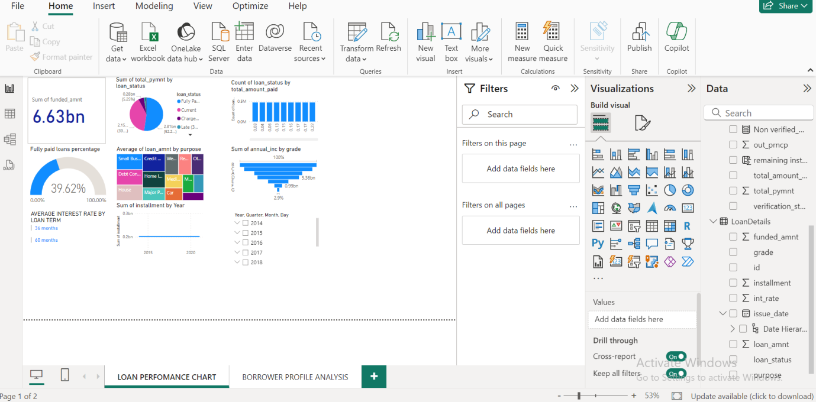

**REPORT 2 SUMMARY**

|  |  |
| --- | --- |
| **VISUAL** | **PURPOSE** |
| **KPI** | **Shows the sum of total payment, trends, and loan amounts** |
| **CARD** | **Display average annual income** |
| **CARD** | **Counts non-verified borrowers** |
| **MULTI –ROW CARD** | **Shows average debt-to-income by delinquency status** |
| **TABLE** | **Display total loan amount by home ownership** |
| **DONUT CHART** | **Visualizes average remaining principal by verification status** |
| **BAR CHART** | **Shows delinquencies by home ownership, filtered to show mortgage,rent,own.** |
| **TREE CHART** | **Shows max remaining instalments by employement length** |
| **LINE CHART** | **Visualizes total amount paid and funded amount over time** |
| **SLICER** | **Allows filtering by loan purpose** |
|  |  |

**Borrower Profile Analysis**

